Kopfrechnen-Staffel 1
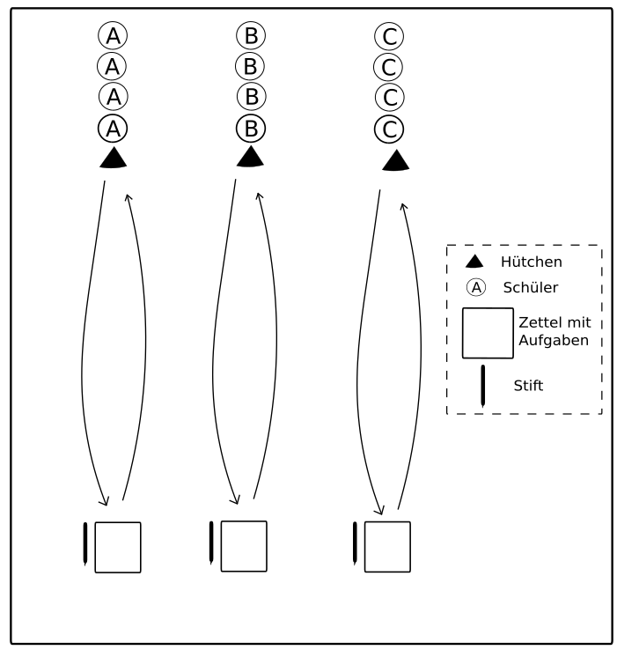
Es bilden sich 4-5 Teams. Diese stehen in Reihen hinter einem Hütchen. Der jeweilige Erste eines Teams rennt zu einem Zettel, auf dem Kopfrechnen-Aufgaben stehen. Er darf nur eine Aufgabe lösen und läuft dann wieder zurück. Dann rennt der Zweite eines Teams los. Sieger ist das Team, welches zuerst alle Aufgaben korrekt gelöst hat.

45 + 63 = | 12 x 6 = | 4 x 3 =
7 x 6 = | 41 – 8 = | 2 x 14 =
34 + 74 = | 99 – 64 = | 4 x 8 =
6 x 1 = | 28 + 65 = | 75 + 2 =
3 x 7 = | 5 x 8 = | 9 x 10 =
21 – 6 = | 39 + 4 = | 52 – 8 =
7 x 9 = | 7 x 7 = | 8 x 2 =

45 + 63 = | 12 x 6 = | 4 x 3 =
7 x 6 = | 41 – 8 = | 2 x 14 =
34 + 74 = | 99 – 64 = | 4 x 8 =
6 x 1 = | 28 + 65 = | 75 + 2 =
3 x 7 = | 5 x 8 = | 9 x 10 =
21 – 6 = | 39 + 4 = | 52 – 8 =
7 x 9 = | 7 x 7 = | 8 x 2 =

45 + 63 = | 12 x 6 = | 4 x 3 =
7 x 6 = | 41 – 8 = | 2 x 14 =
34 + 74 = | 99 – 64 = | 4 x 8 =
6 x 1 = | 28 + 65 = | 75 + 2 =
3 x 7 = | 5 x 8 = | 9 x 10 =
21 – 6 = | 39 + 4 = | 52 – 8 =
7 x 9 = | 7 x 7 = | 8 x 2 =

45 + 63 = | 12 x 6 = | 4 x 3 =
7 x 6 = | 41 – 8 = | 2 x 14 =
34 + 74 = | 99 – 64 = | 4 x 8 =
6 x 1 = | 28 + 65 = | 75 + 2 =
3 x 7 = | 5 x 8 = | 9 x 10 =
21 – 6 = | 39 + 4 = | 52 – 8 =
7 x 9 = | 7 x 7 = | 8 x 2 =

45 + 63 = | 12 x 6 = | 4 x 3 =
7 x 6 = | 41 – 8 = | 2 x 14 =
34 + 74 = | 99 – 64 = | 4 x 8 =
6 x 1 = | 28 + 65 = | 75 + 2 =
3 x 7 = | 5 x 8 = | 9 x 10 =
21 – 6 = | 39 + 4 = | 52 – 8 =
7 x 9 = | 7 x 7 = | 8 x 2 =

45 + 63 = | 12 x 6 = | 4 x 3 =
7 x 6 = | 41 – 8 = | 2 x 14 =
34 + 74 = | 99 – 64 = | 4 x 8 =
6 x 1 = | 28 + 65 = | 75 + 2 =
3 x 7 = | 5 x 8 = | 9 x 10 =
21 – 6 = | 39 + 4 = | 52 – 8 =
7 x 9 = | 7 x 7 = | 8 x 2 =

